

CS214: Design & Analysis of Algorithms SCIMS, FSTE

Final Examination Semester II, 2019

F2F/Blended Mode

Duration of Exam: 3 hours + 10 minutes

Reading Time: 10 minutes

Writing Time: 3 hours

Total Marks: 40

Instructions:

1. Write your answers in the space provided in this Question Paper.
2. Answer all questions. There are 12 questions and all questions are compulsory.
3. This exam is worth 40% of your overall mark. The minimum mark to pass the final exam is 16/40.
4. Total number of pages including this cover sheet is 14.
5. This is a closed book exam. No printed materials and electronic devices are allowed.

ID:___________________________ Name:_____________________________

SeatNo: _______________________

1. Define the Input Range:
- Let the parameter, nnn, represent a non-negative integer.
- The student should define a suitable range of nnn values (e.g., from 1 to a sufficiently large number), ensuring the range is broad enough to observe performance differences.
2. Measure Execution Time:
- For each value of nnn, measure the execution time of both functions.
- This can be done using built-in timing functions in the programming language, such as System.nanoTime() in Java or time.time() in Python.
- Collect execution time for each function over multiple runs to minimize noise (e.g., averaging the results of 5–10 runs for each nnn).
3. Plot the Results:
- Plot the measured execution times against nnn on a graph (with nnn on the x-axis and time on the y-axis).
- This helps visualize how the execution time grows as nnn increases.
4. Analyze the Growth Patterns:
- Observe the trend of the execution times. Common growth patterns include:
  - Constant (O(1)): The execution time remains constant regardless of nnn.
  - Linear (O(n)): The execution time grows proportionally with nnn.
  - Quadratic (O(n^2)): The execution time grows proportionally with the square of nnn.
  - Logarithmic (O(log n)): The execution time grows logarithmically as nnn increases.
  - Exponential (O(2^n)): The execution time doubles with each increase in nnn.
- The student should compare the observed growth rates for the two functions.
5. Fit the Time Complexity Model:
- Using the graph, fit the data to standard complexity classes (e.g., O(1), O(n), O(n^2)) by comparing the shape of the curve.
- Alternatively, the student can calculate the ratios of execution times for successive nnn values to approximate the complexity. For example:
  - If the ratio stays constant, it may suggest O(n).
  - If the ratio grows, it could indicate O(n^2) or higher.
  - If the ratio decreases, it could suggest O(log n).
6. Confirm Results with Larger nnn:
- Test larger values of nnn to verify the time complexity approximation.
- Sometimes smaller values of nnn can be deceptive, especially if the constant factors dominate performance.
Conclusion:
The student can approximate the every-case time complexity by empirically measuring execution time for varying input sizes, plotting the results, and identifying the trend that matches known complexity patterns.

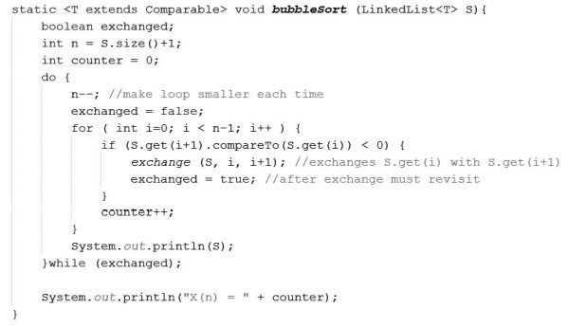
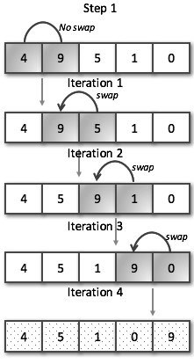
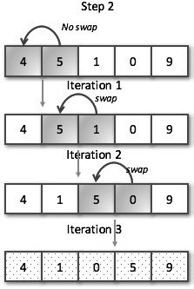

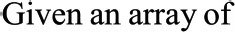
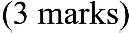

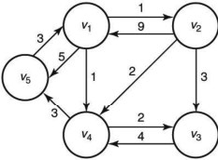
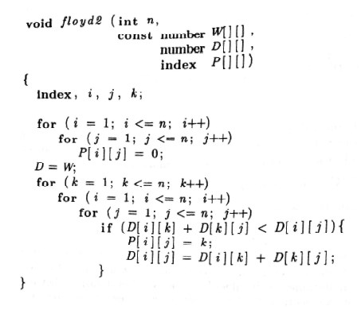
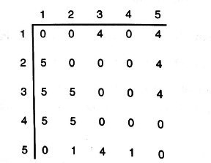
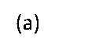
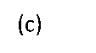
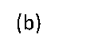
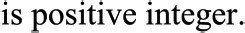

1. Overlapping Subproblems:
The given recursive relation for the problem is:
f(n)=f(n−1)+(n−1)×f(n−2)f(n) = f(n-1) + (n-1) \times f(n-2)f(n)=f(n−1)+(n−1)×f(n−2)
This recurrence breaks the problem into smaller subproblems, but many of these subproblems overlap. For example, solving for f(n−1)f(n-1)f(n−1) and f(n−2)f(n-2)f(n−2) involves recursively solving for f(n−2)f(n-2)f(n−2), f(n−3)f(n-3)f(n−3), and so on. These overlapping subproblems make dynamic programming (DP) more efficient because DP stores results and avoids redundant calculations by using memoization or tabulation.
2. Optimal Substructure:
The problem can be solved by solving its subproblems optimally (i.e., f(n)f(n)f(n) is computed by knowing the results of f(n−1)f(n-1)f(n−1) and f(n−2)f(n-2)f(n−2)). This characteristic makes dynamic programming ideal, as it is specifically designed for problems with optimal substructure.
3. Divide & Conquer Limitations:
- Divide and conquer breaks the problem into non-overlapping subproblems and combines their solutions. However, the Friends Pairing Problem has overlapping subproblems, meaning that divide and conquer would inefficiently repeat calculations for the same inputs.
- In addition, divide and conquer usually works well for problems with no or minimal dependencies between subproblems, which is not the case here because each subproblem relies on the result of the previous subproblem.
4. Time Complexity:
- Dynamic programming solves the problem in O(n)O(n)O(n) time by solving each subproblem once and storing the results.
- Divide and conquer, on the other hand, would involve recomputation, leading to an exponential time complexity of O(2n)O(2^n)O(2n) due to repeated function calls.
Conclusion:
Dynamic programming is a more suitable approach for solving the Friends Pairing Problem because of its ability to handle overlapping subproblems efficiently, resulting in a much faster solution compared to divide and conquer.

Given that deterministic approaches like dynamic programming, divide and conquer, and greedy algorithms result in no better than O(2n)O(2^n)O(2n) average-case time complexity for preparing a satisfactory USP timetable, this suggests the problem is computationally hard, likely NP-complete or NP-hard. Solving such problems exactly is infeasible for large inputs due to exponential time complexity. In this case, heuristic or metaheuristic approaches would be more practical.
How I Would Solve the Problem:
- Use Approximation or Heuristic Algorithms:
  - Genetic algorithms: This evolutionary approach simulates the process of natural selection. It uses a population of candidate solutions (timetables) and evolves them through selection, crossover, and mutation to find a near-optimal solution over several generations.
  - Simulated Annealing: This technique explores the solution space by accepting not only better solutions but also worse ones with a decreasing probability, allowing it to escape local optima and find a good, if not optimal, solution.
  - Tabu Search: This is a local search-based heuristic that keeps track of previously visited solutions (tabu list) to avoid cycling back and improve the exploration of the search space.
  - Constraint Satisfaction Heuristics: If the problem is framed as a constraint satisfaction problem (CSP), specific heuristics like backtracking with forward checking, constraint propagation, or using more intelligent variable ordering can help find good solutions.
- Would I Be Able to Produce the Optimum Timetable?
  - No, I cannot guarantee the optimum (best possible) timetable in a reasonable time frame, especially for large instances of the problem. Given the problem’s hardness, finding the true optimum in polynomial time is impractical.
  - However, using heuristic or metaheuristic methods, I can produce a near-optimal or satisfactory solution within a reasonable time frame, which often works well in real-world applications where "good enough" solutions are acceptable.
Conclusion:
To solve the USP timetable problem efficiently, I would use metaheuristic approaches such as genetic algorithms, simulated annealing, or tabu search. While these methods may not guarantee the optimum solution, they can deliver high-quality, near-optimal solutions within a reasonable time, making them suitable for such computationally complex problems.

ID: ______________________

8. For the given phrase “tuition at institution”, find its corresponding encoded value using Huffman’s algorithm and calculate the ratio of compression achieved. (4 Marks) Note: Each character in a phrase occupies 1 byte of memory and ignore the blanks in the given phrase.

Page 9
ID: ______________________

9. (a) Write a pseudo code to disperse change from vending machine using greedy approach
(2 Marks)

(b) Apply Greedy approach to give a change of 78c from available coins 54c, 44c, 34c, 14c, 4c, 2c. Justify whether you have got locally optimal or globally optimal solution. (1 Mark)

Page 10
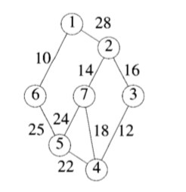
ID: ______________________

10. (a) Find the minimum cost spanning tree for the given graph using prim’s and kruskal’s algorithm. Show the output after every stage while using these algorithms (4 Marks)

Page 11
ID: ______________________

(b) Which is the better of two algorithms for the above graph? Explain your answer. (1 Mark)

11. Use the single source shortest path algorithm to obtain in nondecreasing order the lengths of the shortest paths from vertex 1 to all the remaining vertices in the digraph given below.
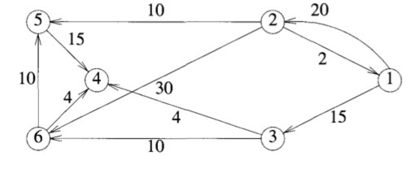
(2 Marks)

Page 12
ID: ______________________

12. Consider the 0-1 Knapsack problem with four different items having different weights and profit values:
Item 1 (2 kg, $3) Item 2 (3kg, $5) Item 3 (4kg, $6) Item 4 (5kg, $10)
The knapsack has a capacity of 8kg

(a) Use the greedy approach to compute the optimal profit in filling the knapsack ( 1 Mark)

(b) Use the backtracking algorithm for the above 0-1 knapsack problem to maximize the profit and show the state space tree (4 Marks)

Page 13
ID: ______________________

(c) Which is the better of two approaches above? Explain your answer. (1 Mark)

Page 14

